Noun Complement

✅ What Is a Noun Complement?
# Source: AI Source: Provided by: [Data Path: Persons Table -> ID Column: 1, Name_En Column: Motasem Essam] -> From: [ChatGPT] on [8/4/2025]
A Noun Complement is a word, phrase, or clause that completes the meaning of a noun.
It usually follows the noun and provides essential information—such as content, identity, or result—often answering what, who, or that...

🔸 Key Features:
# Source: AI Source: Provided by: [Data Path: Persons Table -> ID Column: 1, Name_En Column: Motasem Essam] -> From: [ChatGPT] on [8/4/2025]
- Appears immediately after a noun
- Provides essential (not optional) meaning to the noun
- Common with abstract nouns like:
fact, idea, claim, hope, possibility, suggestion, statement, belief
- Often takes the form of:
  - A that-clause
  - A to-infinitive phrase
  - A wh-clause

🔸 Examples in Sentences:
# Source: AI Source: Provided by: [Data Path: Persons Table -> ID Column: 1, Name_En Column: Motasem Essam] -> From: [ChatGPT] on [8/4/2025]
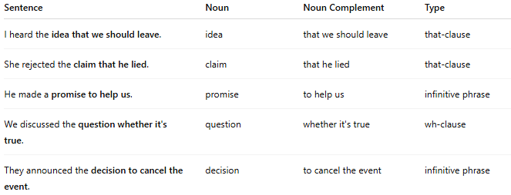
Sentence | Noun | Noun Complement | Type
I heard the idea that we should leave. | idea | that we should leave | that-clause
She rejected the claim that he lied. | claim | that he lied | that-clause
He made a promise to help us. | promise | to help us | infinitive phrase
We discussed the question whether it's true. | question | whether it's true | wh-clause
They announced the decision to cancel the event. | decision | to cancel the event | infinitive phrase

🔸 Noun Complement vs Adjective Modifier:
# Source: AI Source: Provided by: [Data Path: Persons Table -> ID Column: 1, Name_En Column: Motasem Essam] -> From: [ChatGPT] on [8/4/2025]
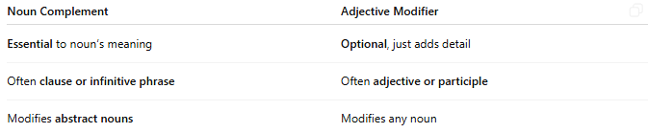
Noun Complement | Adjective Modifier
Essential to noun’s meaning | Optional, just adds detail
Often clause or infinitive phrase | Often adjective or participle
Modifies abstract nouns | Modifies any noun
Example:
- “The fact that she left upset him.” → noun complement
- “The tired woman sat down.” → adjective modifier

🔸 Tip to Identify a Noun Complement:
# Source: AI Source: Provided by: [Data Path: Persons Table -> ID Column: 1, Name_En Column: Motasem Essam] -> From: [ChatGPT] on [8/4/2025]
- Look for an abstract noun.
- Ask: “Does the information after it complete its meaning?”
- Try removing it:
  - “He rejected the claim.” (Incomplete)
  - “He rejected the claim that he lied.” ✅

